Calculus and Graphs
Consider the graphs below. For each function, make a rough sketch of the graph of its derivative and an antiderivative. More importantly, explain in detail exactly why the graphs must have the shape you drew.
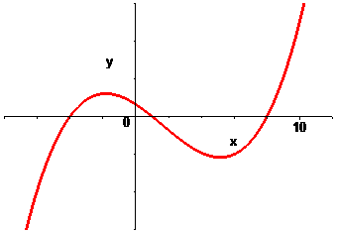

Graph of Derivative Explanation

Graph of an Antiderivative Explanation

Consider the graphs below. For each function, make a rough sketch of the graph of its derivative and an antiderivative. More importantly, explain in detail exactly why the graphs must have the shape you drew.
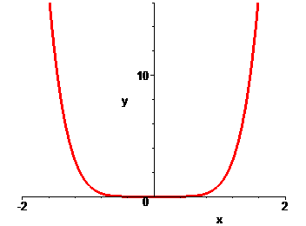

Graph of Derivative Explanation

Graph of an Antiderivative Explanation

Consider the graphs below. For each function, make a rough sketch of the graph of its derivative and an antiderivative. More importantly, explain in detail exactly why the graphs must have the shape you drew.
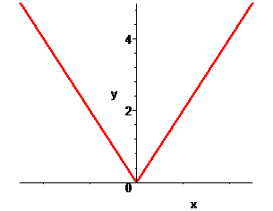

Graph of Derivative Explanation

Graph of an Antiderivative Explanation

Consider the graphs below. For each function, make a rough sketch of the graph of its derivative and an antiderivative. More importantly, explain in detail exactly why the graphs must have the shape you drew.
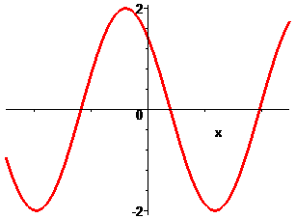

Graph of Derivative Explanation

Graph of an Antiderivative Explanation

Consider the graphs below. For each function, make a rough sketch of the graph of its derivative and an antiderivative. More importantly, explain in detail exactly why the graphs must have the shape you drew.
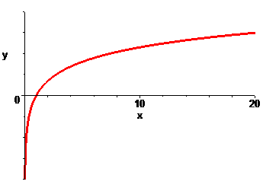

Graph of Derivative Explanation

Graph of an Antiderivative Explanation

